Antigravity is a concept that still people consider a science-fiction utopia. Information on antigravity research has begun to appear in the media lately. In documents preserved in ancient Sanskrit in ancient India over 15,000 years ago, an anti-gravity propulsion method is presented as: a centrifugal force strong enough to counteract all gravitational pull. In 1992 the scientist Eugen Podkletnov, achivd a very complex device with superconductors (-197⁰ C), using a high-speed rotation(5000 rot/min) in liquid nitrogen and ultra-powerful electric field (1 M V). Podkletnov claimed a 2% weight reduction. Unfortunately the experiment could never be repeated. 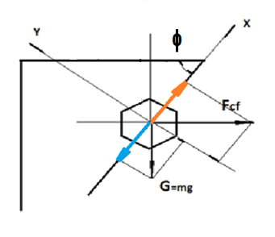
Fig. 1 MAGIC Engine. Scheme of principle The MAGIC Engine is a device by which rotating, cancels 100% of the weight of the masses.
This method was applied when designing, experimenting and making the centrifugal inertial anti-gravitational engine.
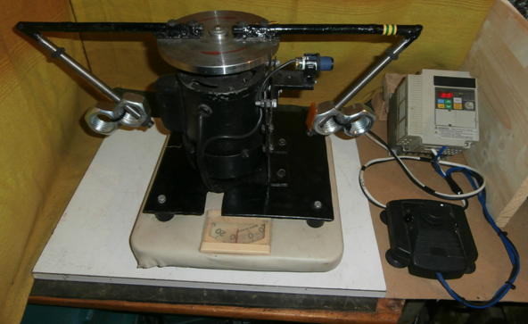
Fig. 2 MAGIC Engine. Experimental Model
MAGIC Engine uses a classical electric motor and a drive system to rotate the weights (batteries, fuel, hydraulic oil, etc. ) of the device at a certain angle and a certain speed so that weights should "float". A powerful centrifugal force is generated, which totally cancels the gravitational force of the rotated masses. 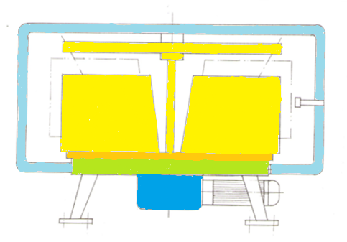
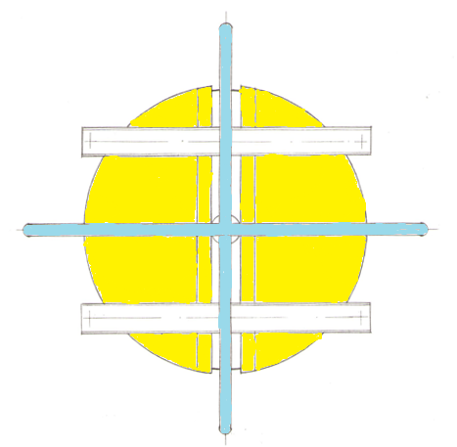
Fig. 3 Real MAGIC Engine

By equipping cars, motorcycles, drones, helicopters, planes, missiles, etc., with this MAGIC Engine, a reduction of their weight, a decrease of their fuel consumption, as well as an increase of their payload are achieved. The MAGIC Engine has the following advantages: - a simple construction and cheap maintenance - high safety in operation - there is no danger of fire or explosion when operating - low noise in operation (maximum 10 dB) - it becomes operational in a short time (10 sec) - it does not produce turbulence or running air - a technological reduced impact on industry when implemented in production - low sale price. Some general possible uses of different equiped systems with MAGIC Engine are presented in the following pictures.
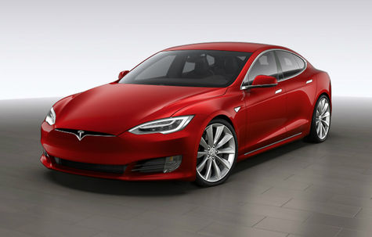 Fig.4 Electric car An electric car weighs 2000 Kg, half of which represents the weight of the batteries. MAGIC Engine may reduce the weight of the car (50%) and double the active driving time.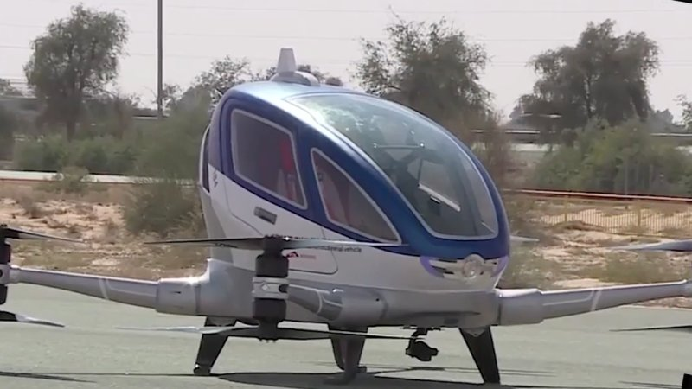 Fig. 5 Drona A two people drone weighs is 400 Kg, the

weight of the batteries is 200 Kg and the operating time is 30 minutes. MAGIC Engine, will reduce the weight and increase twice the operating time. 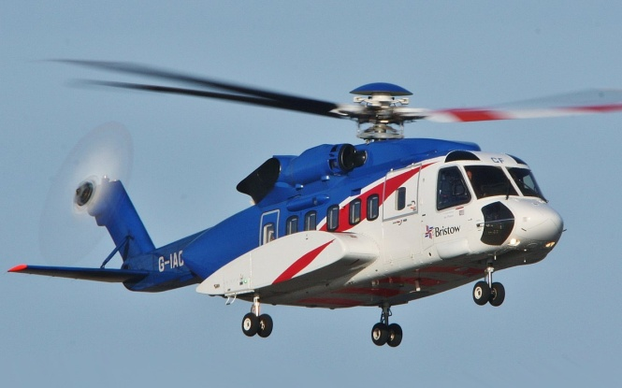 Fig.6 Helicopter If MAGIC Engine is used, the weight of the helicopter can be reduced up to 30%.
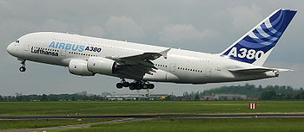Fig.7 Passenger Airplane If a passenger airplane weighing 300 tons, uses MAGIC Engine will reduce the weight of the plane and its fuel consumption by about 30%. It will also increase its payload. 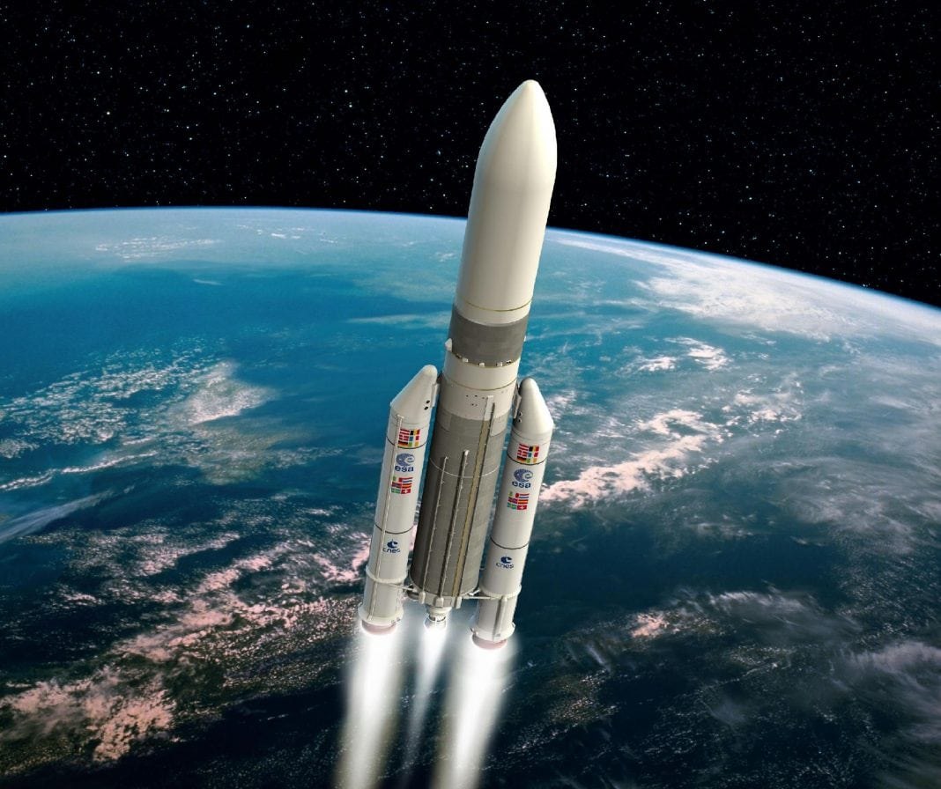 Fig. 8 Spaceship A spacecraft weighs 2000 tons, 80% representing its fuel. If we equip it with MAGIC Engine, the weight will be reduced as well as its fuel consumption, while its payload will be increased.
Dr. Eng. Puiu Caneparu tel: 0040/722/210443 e-mail: pcaneparu@yahoo.com

